


WebMinds, Inc.

NetOptimizerTM
Version v5.0

User Manual
Version 1.0

Dec 29, 2023

Copyright © WebMinds, Inc., 2024
All Rights Reserved
This publication is protected by federal copyright law. No part of this publication may be copied or distributed, stored in a retrieval system, or translated into any human or computer language in any form or by any means, electronic, mechanical, magnetic, manual or otherwise, or disclosed to third parties without the express written permission of WebMinds, Inc.

WebMinds, Inc. makes no representation or warranties with respect to the contents hereof and specifically disclaim any implied warranties of merchantability or fitness for a particular purpose. Further, WebMinds, Inc. reserves the right to revise this publication and to make changes from time to time in the contents hereof without obligation of WebMinds, Inc. to notify any person or organization of such revision or changes.

WebMinds, Inc. has prepared this guide for use by WebMinds, Inc. personnel and authorized third parties as a guide to proper operation and/or maintenance of WebMinds, Inc. equipment and software. The drawings and specifications contained herein are the property of WebMinds, Inc.

Trademarked names may appear throughout this user manual. Rather than list the names and entities that own the trademarks or insert a trademark symbol with each mention of the trademarked name, the names are used only for editorial purposes and to the benefit of the trademark owner with no intention of infringing upon that trademark.

Address comments and corrections to:

WebMinds, Inc.
950 N Collier Blvd. Suite 400
Marco Island FL 34145
USA

Revision History
Date | Release | Revision DESCRIPTION | MODIFIED BY
Dec 18, 2023 | 0.1 | Initial draft | David A. Flynn
Dec 29, 2023 | 1.0 | First base lined user manual | David A. Flynn

About this User Manual
This section briefly describes key details of this user manual –

Purpose of this User Manual
The purpose of this user manual is to assist the end users of the NetOptimizerTM application.

Scope of this User Manual
The section describes the topics in and out of scope of this user manual –

In Scope of this User Manual
The scope of this user manual includes the description and usage of the NetOptimizerTM application.

Out of Scope of this User Manual
The scope of this user manual does not include –
- the detailed installation process of NetOptimizerTM application
- the usage of the features and functionalities of your operating system

Intended Audience of this User Manual
The intended audiences of this user manual are –
- end users of the NetOptimizerTM application

Typographical Conventions / Customaries used in this User Manual
The typographical conventions used in this user manual include the following –

- Note: The purpose of this typographical convention is to provide important information corresponding to an already stated fact. This is how we depict a note in this user manual –
Note:<Note Text><Note Text><Note Text><Note Text><Note Text><Note Text><Note Text><Note Text><Note Text><Note Text><Note Text><Note Text><Note Text><Note Text>

- Tip: The purpose of this typographical convention is to provide additional information supplementing an already stated fact. This is how we depict a tip in this user manual –
Tip:<Tip Text><Tip Text><Tip Text><Tip Text><Tip Text><Tip Text><Tip Text><Tip Text><Tip Text><Tip Text><Tip Text><Tip Text><Tip Text><Tip Text><Tip Text><Tip Text><Tip Text>

- Warning: The purpose of this typographical convention is to provide critical information corresponding to an already stated fact. This is how we depict a warning in this user manual –
Warning:<Warning Text><Warning Text><Warning Text><Warning Text><Warning Text><Warning Text><Warning Text><Warning Text><Warning Text><Warning Text><Warning Text>

- Reference: The purpose of this typographical convention is to refer you to another section in this user manual or another document or to an external reference. A reference is depicted in the following manner in this user manual –
Reference: To read detailed steps, navigate to <Chapter Name> chapter by clicking this link.

or

Reference: For more information, navigate to <Chapter Name> chapter by clicking this link.

Abbreviations / Acronyms used in this User Manual
The table below describes the abbreviations / acronyms used in this user manual –
Abbreviation | Description
GUI, UI | Graphical User Interface, User Interface
IPR | Intellectual Property Rights
NO | NetOptimizer
TM | Trade Mark
TOC, TOT, TOF | Table of Contents, Table of Tables, Table of Figures
PC | Personal Computer
FAQs | Frequently Asked Questions

Organization of this User Manual
This user manual contains 9 chapters & 1 appendices as indicated below –
chapter | Description
Chapter 1 | Introduction
Chapter 2 | Getting Started
Chapter 3 | Using the Auto Mode
Chapter 4 | Using the Advanced Mode
Chapter 5 | Viewing the Wi-Fi Passwords
Chapter 6 | Using the Browser Cleanup Feature
Chapter 7 | Using the Diagnostic Troubleshooting Feature
Chapter 8 | Activating your NetOptimizer TM Installation
Chapter 9 | Removing your NetOptimizer TM License Key
Appendix A | Frequently Asked Questions

Terms Used in this User Manual
The below table briefly describes the terms utilized in this user manual –
chapter | Description
End User | An operator or user of the NetOptimizer TM application.

Table of Contents
Revision History ii
About this User Manual iii
Purpose of this User Manual iii
Scope of this User Manual iii
In Scope of this User Manual iii
Out of Scope of this User Manual iii
Intended Audience of this User Manual iii
Typographical Conventions / Customaries used in this User Manual iv
Abbreviations / Acronyms used in this User Manual v
Organization of this User Manual v
Terms Used in this User Manual v
Table of Contents 6
Table of Figures 7
Chapter - 1. Introduction 9
Chapter - 2. Getting Started 10
Chapter - 3. Using the Auto Mode 12
Chapter - 4. Using the Advanced Mode 15
4.1 Optimizing Data Caching Settings 16
4.2 Optimizing DNS Server Settings 18
4.3 Optimizing Host Resolution Priority Settings 21
4.4 Optimizing I/O Latency Settings 23
4.5 Optimizing Internet Connection Speed Settings 25
4.6 Optimizing Metered Connection Settings 27
4.7 Optimizing Network Efficiency Settings 29
4.8 Optimizing Network Performance Settings 31
4.9 Optimizing Network Throughput Settings 33
4.10 Optimizing Packet Coalescing Settings 36
4.11 Optimizing QoS Reserved Bandwidth Settings 38
Chapter - 5. Viewing the Wi-Fi Passwords 41
Chapter - 6. Using the Browser Cleanup Feature 42
Chapter - 7. Using the Diagnostic Troubleshooting Feature 45
Chapter - 8. Activating your NetOptimizerTM Installation 46
Chapter - 9. Removing your NetOptimizerTM License Key 48
Appendix - A. Frequently Asked Questions (FAQs) 50
Index 54

Table of Figures
Figure 1 – Downloading the NetOptimizerTM application installer executable file 9
Figure 2 – NetOptimizerTM default screen 10
Figure 3 – Running the Auto Mode wizard 12
Figure 4 – Automatic execution of the Auto Mode system analysis wizard 12
Figure 5 – Apply optimized network settings? 13
Figure 6 – Key application popup 13
Figure 7 – Successful application of your license key 14
Figure 8 – Restarting your system 14
Figure 9 – Using the Advanced Mode 15
Figure 10 – Advanced Mode screen 15
Figure 11 – Advanced Mode screen 16
Figure 12 – Data caching easel 16
Figure 13 – Advanced Mode screen 18
Figure 14 – DNS servers easel 19
Figure 15 – DNS server selection popup 19
Figure 16 – Advanced Mode screen 21
Figure 17 – Data caching easel 22
Figure 18 – Advanced Mode screen 23
Figure 19 –I/O latency easel 24
Figure 20 – Advanced Mode screen 25
Figure 21 – Internet connection speed easel 26
Figure 22 – Advanced Mode screen 27
Figure 23 – Metered connection easel 28
Figure 24 – Advanced Mode screen 29
Figure 25 – Network efficiency easel 30
Figure 26 – Advanced Mode screen 31
Figure 27 – Network performance easel 32
Figure 28 – Advanced Mode screen 33
Figure 29 – Network throughput easel 34
Figure 30 – Advanced Mode screen 36
Figure 31 – Packet coalescing easel 37
Figure 32 – Advanced Mode screen 38
Figure 33 – QoS reserved bandwidth easel 39
Figure 34 – Viewing the Wi-Fi Passwords 41
Figure 35 – Automatic execution of the Auto Mode system analysis wizard 41
Figure 36 – Using the Browser Cleanup Feature 42
Figure 37 – Browser cleanup screen 42
Figure 38 – Querying for Cleanup task confirmation 43
Figure 39 – Querying for closing open web-browsers 43
Figure 40 – Successful Operation completion status message 44
Figure 41 – Browser cleanup screen 44
Figure 42 – Using the Diagnostic Troubleshooting Feature 45
Figure 43 – Diagnostic troubleshooting wizard 45
Figure 44 – Activating your NetOptimizerTM Installation 46
Figure 45 – Key application popup 46
Figure 46 – Successful application of your license key 47
Figure 47 – Viewing your license key details 47
Figure 48 – Removing your NetOptimizerTM License Key 48
Figure 49 – Viewing your license key details 48
Figure 50 – License key deactivation confirmation message 49
Figure 51 – License key deactivation successfully status message 49

Introduction
In today’s digital age, a slow wifi connection can be a major source of frustration. Whether you’re trying to stream your favorite show, work from home, or simply browse the internet, a sluggish connection can bring everything to a halt.

Reference: To read about common issues which may contribute to slowing your wifi connection, visit https://www.netoptimizer.com/how-to-fix-slow-wifi/

Once you are sure that all of the issues mentioned in the article above have been taken care off, you can download the NetOptimizer TM application from the Download link available in the menu on the NetOptimizer TM homepage or by clicking the Free Download button as depicted in the figure below –
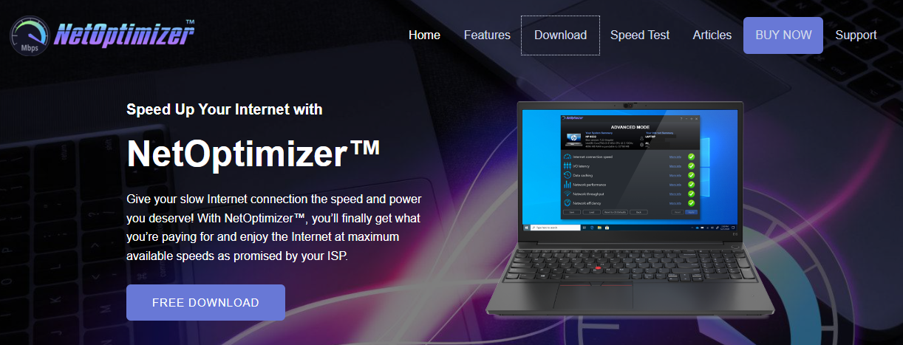
Figure 1 – Downloading the NetOptimizerTM application installer executable file
Tip: After you click the above-mentioned links, you may be warned by your web-browser about a potential security risk due to the downloaded executable file. Please authorize this file.
You can follow the installation wizard by launching the downloaded NetOptimizer TM installer executable file to install the NetOptimizer TM application on your system.
Tip: After you open the downloaded executable file, you may be warned by your operating system before you install this application on your system. Please authorize your operating system to continue installing this application at this step.

The next chapter describes steps that enable you to get started with the NetOptimizer TM application.

Getting Started
After you launch the NetOptimizer application, your internet summary details are fetched and the default screen is displayed as depicted in the figure below –
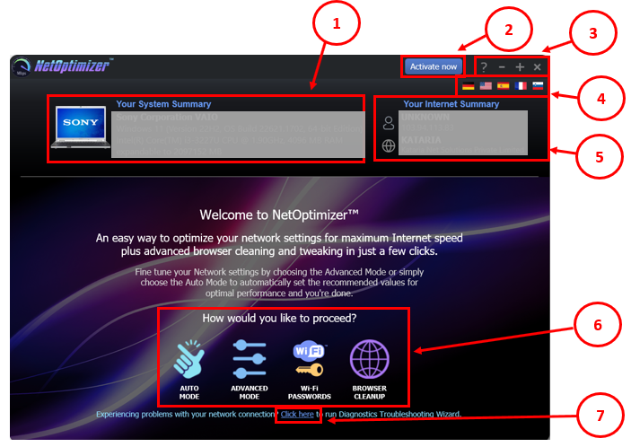
Figure 2 – NetOptimizerTM default screen
Below is a description of the screen elements of the default screen of the NetOptimizerTM application.
NO. | DESCRIPTION
1 | This section of the screen displays your system summary details.
2 | Clicking the Activate Now button enables you to activate your subscription plan by specifying your email address and the key provided to you after you purchase a subscription plan suitable to you.  Reference: To read the detailed steps, navigate to Activating your NetOptimizerTM Installation chapter by clicking this link.
3 | Below are the descriptions of the buttons available in this section of the screen –  - Question Mark (?) – Clicking this button opens the About popup which displays the details of your NetOptimizer installation. E.g. license details, etc.  - Minus (-) – Clicking this button enables you to minimize this screen  - Plus (+) – Clicking this button enables you to maximize this screen  - Cross (x) – Clicking this button enables you to close this screen
4 | Clicking any of the national flags enables you to change the display language of your NetOptimizer installation.
5 | This section of the screen displays your internet summary details.
6 | Below are the descriptions of the buttons available in this section of the screen –  - Auto Mode – Clicking this button enables you to run the NetOptimizer TM wizard in automatic mode.  Reference: To read detailed steps, navigate to Using the Auto Mode chapter by clicking this link.  - Advanced Mode – Clicking this button enables you to run the NetOptimizer TM wizard in advanced mode  Reference: To read detailed steps, navigate to Using the Advanced Mode chapter by clicking this link.  - Wi-Fi Passwords – Clicking this button enables you to view the password of the wifi connection that your system is connected to.  Reference: To read detailed steps, navigate to Viewing the Wi-Fi Passwords chapter by clicking this link.  - Browser Cleanup – Clicking this button enables you to clean up the cache memory of the web browser of your choice  Reference: To read detailed steps, navigate to Using the Browser Cleanup Feature chapter by clicking this link.
7 | Diagnostic Troubleshooting – Clicking this link enables you to launch the Network Diagnostic Troubleshooting wizard of your operating system.  Reference: To read the detailed steps, navigate to Using the Diagnostic Troubleshooting Feature chapter by clicking this link.

The next chapter describes steps that enable you to use the Auto Mode of the NetOptimizer TM application.

Using the Auto Mode
The steps described below enable you to use the automatic mode of the NetOptimizerTM application –
- From the default screen of the NetOptimizerTM application, click the Auto Mode button as depicted in the figure below.
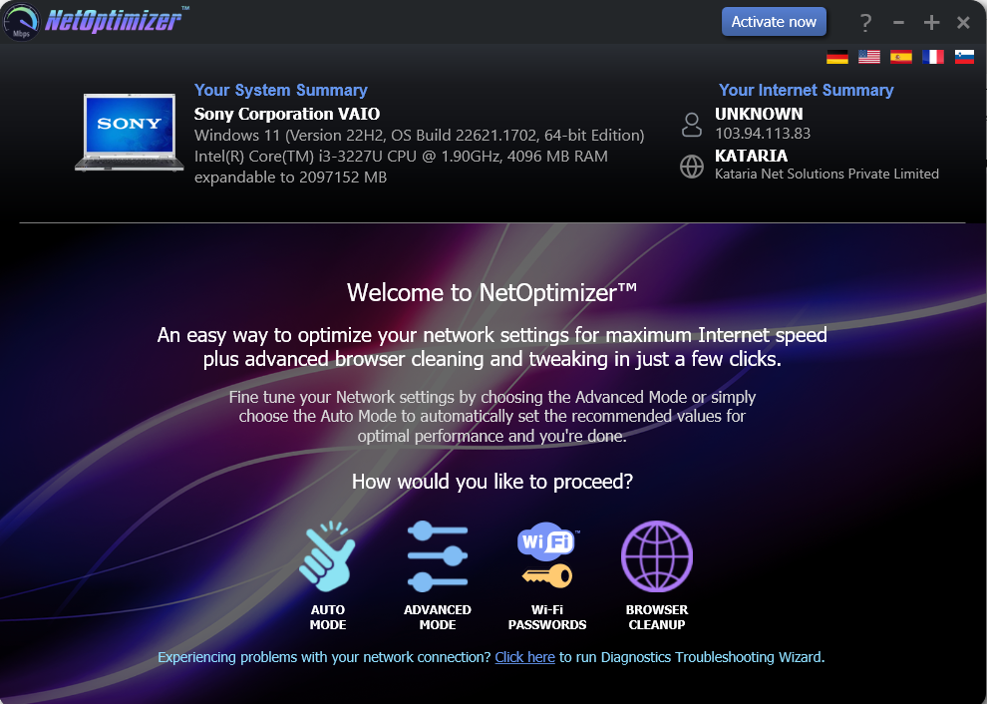
SANITIZED

SANITIZED

Figure 3 – Running the Auto Mode wizard
The Auto Mode screen is displayed as depicted in the figure below –
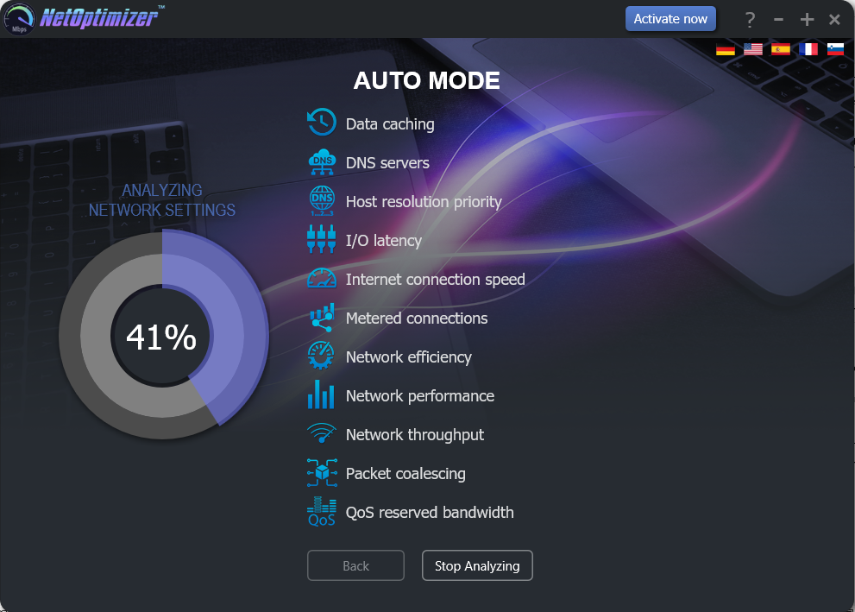
Figure 4 – Automatic execution of the Auto Mode system analysis wizard

The wizard starts analyzing your system as soon as this screen is loaded.
Tip: To stop Analyzing your system click Stop Analyzing as depicted in the figure above. You can also navigate to the default screen by clicking the Back button after the analysis has stopped or completed.

- After the wizard has analyzed your system, the optimized network settings choice popup is displayed as depicted in the figure below –
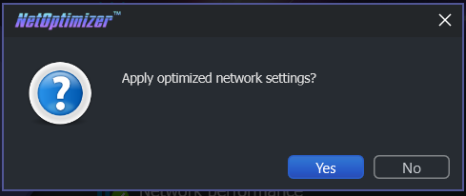
Figure 5 – Apply optimized network settings?
Click No in case you would like to manually change required options before you apply each optimized setting.
Reference: For more information, refer to Using the Advanced Mode chapter by clicking this link.

Click Yes to continue applying the optimized network settings.

- In case you have not purchased and applied a license key in your NetOptimizerTM application installation, a key application popup is displayed as depicted in the figure below –

Figure 6 – Key application popup
- Click the Buy Now button to avail the money saving offer depicted here.
Tip: You will be navigated to the NetOptimizerTM shopping cart web page in your default web browser. You can specify the required details, and click Buy Now on this web page to make your purchase. You will receive an email containing your license key details at the email address specified by you on this web page.

- Once you have received your license key, specify your email address and license key and click the Submit button. After successful validation of the specified key, your NetOptimizerTM installation will be activated and a popup will be displayed confirming the same as depicted in the figure below -
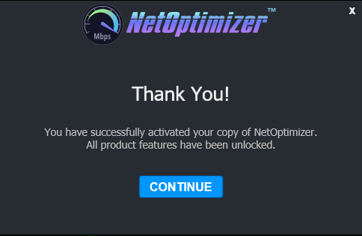
Figure 7 – Successful application of your license key
- Click Continue to continue using the NetOptimizerTM application. The application will create a restore point in your operating system and your optimized network settings will be applied. The application will also query you whether you would like to restart the system as depicted in the figure below.
Tip: The system needs to be restarted to apply the optimized network settings completely and to be loaded by your operating system.

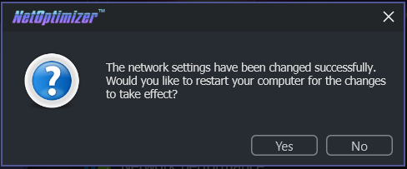
Figure 8 – Restarting your system
- Click Yes to restart your system.

The next chapter describes steps that enable you to use the Advanced Mode of the NetOptimizer TM application.

Using the Advanced Mode
The steps described below enable you to use the advanced mode of the NetOptimizerTM application –
- From the default screen of the NetOptimizerTM application, click the Advanced Mode button as depicted in the figure below.

SANITIZED

SANITIZED

Figure 9 – Using the Advanced Mode
The Advanced Mode screen is displayed as depicted in the figure below –
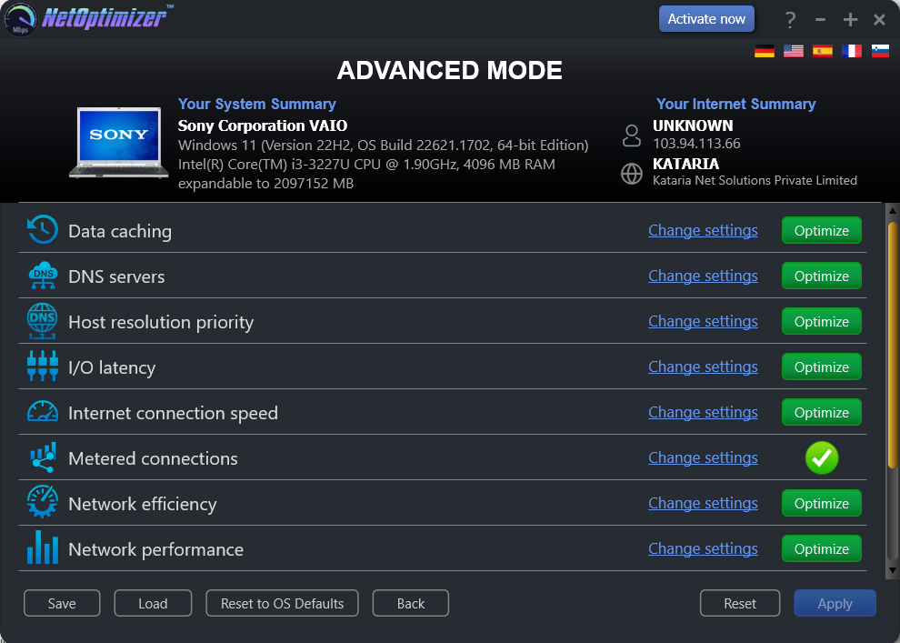
SANITIZED

SANITIZED

Figure 10 – Advanced Mode screen

Perform the steps described in each of the following sub-sections to perform one or more of the network optimization tasks as per your requirements.

Optimizing Data Caching Settings
To optimize data caching, the NetOptimizerTM application optimizes the Time to Live setting.

The Time to Live (TTL) setting tells each of the routers between your system and the intended target server as to how long a data packet should persist in your network while it attempts delivery before abandoning delivery and discarding the aforementioned data packet.

When the value is set high, your computer spends more time waiting for a failed packet to deliver, effectively decreasing the productivity in your network.

The steps described below enable you to optimize data cache settings of your system –
- From the Advanced Mode screen of the NetOptimizerTM application, click the Change Settings link as depicted in the figure below –
SANITIZED

SANITIZED

Figure 11 – Advanced Mode screen

The Data caching easel is opened as depicted in the figure below –
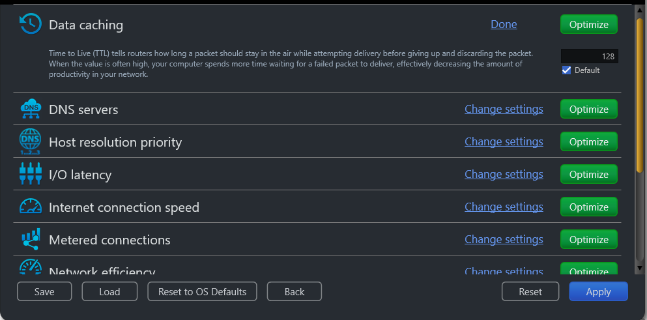
Figure 12 – Data caching easel
- Change the Time to Live (TTL) parameter as per your requirements and click the Optimize button. The green Optimize button is replaced by a blue Pending button.

Tip: Click the Default checkbox to revert to the default parameter settings. You can also click the Done link to close this easel.

Tip: In case you want to revert to the previous settings, click Revert.

Tip: To save your current settings, click Save. The Saves As dialog box is displayed which enables you to specify a folder location on your hard disk drive to save your current settings as a NetOptimizer presets (*.nop) settings file. You can also save these settings on a USB thumb drive in case you want to load these settings on another system.

Tip: To load previously saved settings, click Load. The Open dialog box is displayed which enables you to navigate to the previously saved NetOptimizer presets (*.nop) settings file.

Tip: To revert to the default settings of your operating system, click Reset to OS Defaults. NetOptimizerTM will reset all settings to default values of your Operating System.

Tip: To return to the NetOptimizerTM default screen, click Back.

- Click Apply to apply your updated settings.

Tip: The system will prompt you to Restart your system. Click Yes to continue restarting your system or you can choose to click No to make changes to other settings.

Tip: After you have restarted your system, a green checkbox will be displayed against the optimized and saved setting.

Optimizing DNS Server Settings
To optimize DNS server settings, the NetOptimizerTM application optimizes the Primary DNS & Secondary DNS server IP Address settings.

A Domain Name System (DNS) server is used by your network to locate an IP address corresponding to your domain name. When you open a website by specifying a URL or website link in the address bar of your browser, the DNS Servers resolve the IP Address of the server of this website by matching it with the specified URL or webpage link.

Typically, while restarting or booting up your system, it acquires an IP address from your nearest router using the Dynamic Host Control Protocol (DHCP) settings automatically. Sometimes, while using the DHCP setting, the IP Address of your system and / or the IP Address of the web server take longer than expected to get resolved. This happens primarily because your system first attempts to fetch your network’s Primary and DNS server IP Addresses. This effectively decreases the productivity in your network.

Thus, by manually specifying the Primary & Secondary DNS Server IP Addresses, your system does not require querying your network for the involved DNS Servers. Your system simply attempts IP Address resolution from the explicitly specified IP Addresses of the Primary & Secondary DNS servers.
The steps described below enable you to optimize DNS server settings of your system –
- From the Advanced Mode screen of the NetOptimizerTM application, click the Change Settings link as depicted in the figure below –
SANITIZED

SANITIZED

Figure 13 – Advanced Mode screen

The DNS servers easel is opened as depicted in the figure below –
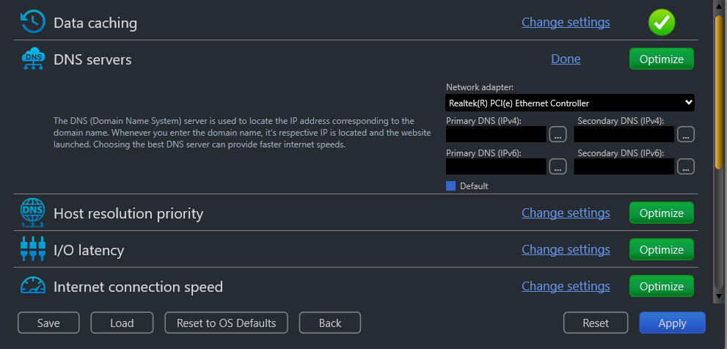
Figure 14 – DNS servers easel
- Select your Network Adapter from the corresponding drop-down box and then specify the Primary DNS & Secondary DNS IP Addresses by typing manually in the corresponding fields as per your requirements. Or you can click the corresponding Ellipsis (…) button next to the Primary DNS field. The DNS server selection popup is displayed as depicted in the figure below –

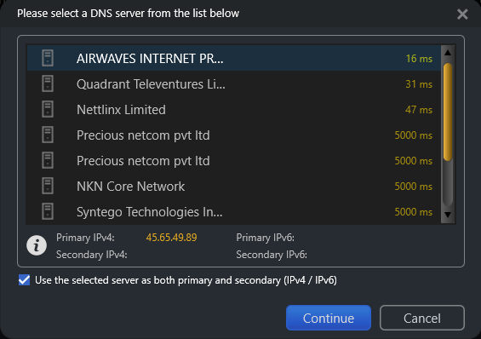
Figure 15 – DNS server selection popup
- Select the DNS Server of your choice and click Continue. The specified IP address is populated in the corresponding DNS server field in the DNS servers easel. Alternatively, you can click Cancel to return to the previous screen. Repeat this step for Secondary DNS also.

- After you are done specifying the Primary and Secondary DNS Server IP Addresses, click the Optimize button. The green Optimize button is replaced by a blue Pending button.

Tip: Click the Default checkbox to revert to the default parameter settings. You can also click the Done link to close this easel.

Tip: In case you want to revert to the previous settings, click Revert.

Tip: To save your current settings, click Save. The Saves As dialog box is displayed which enables you to specify a folder location on your hard disk drive to save your current settings as a NetOptimizer presets (*.nop) settings file.

Tip: To load previously saved settings, click Load. The Open dialog box is displayed which enables you to navigate to the previously saved NetOptimizer presets (*.nop) settings file.

Tip: To revert to the default settings of your operating system, click Reset to OS Defaults. NetOptimizerTM will reset all settings to default values of your Operating System.

Tip: To return to the NetOptimizerTM default screen, click Back.

- Click Apply to apply your updated settings.

Tip: The system will prompt you to Restart your system. Click Yes to continue restarting your system or you can choose to click No to make changes to other settings.

Tip: After you have restarted your system, a green checkbox will be displayed against the optimized and saved setting.

Optimizing Host Resolution Priority Settings
To optimize host resolution priority settings, the NetOptimizerTM application optimizes the Host Resolution Priority to Low or High setting as required.

A High setting decreases the DNS / Hostname resolution priority of the below 4 related processes from their default setting. This decreases their priority compared to the hundreds of other running processes, while keeping their order.
- LocalPriority = 499 default priority – local names cache
- HostPriority = 500 default priority – the HOSTS file
- DnsPriority = 2000 default priority – DNS host resolution
- NetbtPriority = 2001 default priority – NetBT name resolution, including WINS

Tip: Lower numbers mean higher priority compared to other services. The above default values are high; thus, they decrease productivity.

When the value is set to Low, your computer takes lesser time to perform DNS / Hostname resolution, effectively increasing the productivity in your network.

The steps described below enable you to optimize host resolution priority settings of your system –
- From the Advanced Mode screen of the NetOptimizerTM application, click the Change Settings link as depicted in the figure below –
SANITIZED

SANITIZED

Figure 16 – Advanced Mode screen

The Host resolution priority easel is opened as depicted in the figure below –

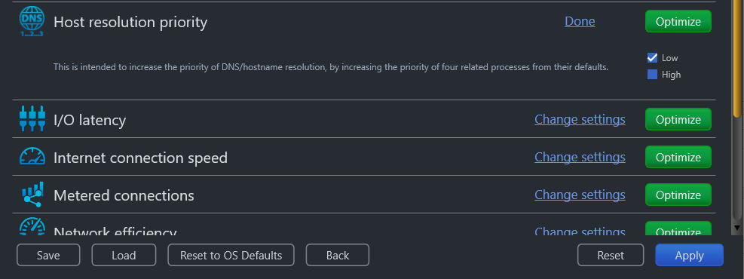
Figure 17 – Data caching easel

- Select the Low checkbox and click the Optimize button. The green Optimize button is replaced by a blue Pending button.

Tip: Click the Default checkbox to revert to the default parameter settings. You can also click the Done link to close this easel.

Tip: In case you want to revert to the previous settings, click Revert.

Tip: To save your current settings, click Save. The Saves As dialog box is displayed which enables you to specify a folder location on your hard disk drive to save your current settings as a NetOptimizer presets (*.nop) settings file. You can also save these settings on a USB thumb drive in case you want to load these settings on another system.

Tip: To load previously saved settings, click Load. The Open dialog box is displayed which enables you to navigate to the previously saved NetOptimizer presets (*.nop) settings file.

Tip: To revert to the default settings of your operating system, click Reset to OS Defaults. NetOptimizerTM will reset all settings to default values of your Operating System.

Tip: To return to the NetOptimizerTM default screen, click Back.

- Click Apply to apply your updated settings.

Tip: The system will prompt you to Restart your system. Click Yes to continue restarting your system or you can choose to click No to make changes to other settings.

Tip: After you have restarted your system, a green checkbox will be displayed against the optimized and saved setting.

Optimizing I/O Latency Settings
To optimize I/O latency settings, the NetOptimizerTM application optimizes the Raw Receive Buffer setting.

The I/O Latency is the time that your system takes by default in all input / output data packet transmission instances. The Disk I/O throughput during Read/Write instances is governed by the size of the Raw Receive Buffers within a server environment. This must be kept optimized to ensure better Disk I/O read / write times. This means it will affect your ability to host something in a high-latency environment. Let's say, for example, you host a game server and tons of people complain about lag. Modifying this value will help reduce the impact of lag. You'd also benefit if you're hosting a website or any other service.

When the value is set higher than the default value, your computer spends lesser time with each Disk I/O action, effectively increasing the productivity in your network.

The steps described below enable you to optimize I/O latency settings of your system –
- From the Advanced Mode screen of the NetOptimizerTM application, click the Change Settings link as depicted in the figure below –
SANITIZED

SANITIZED

Figure 18 – Advanced Mode screen

The I/O latency easel is opened as depicted in the figure below –
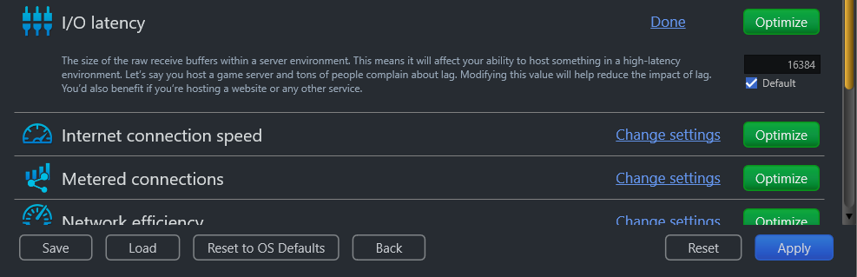
Figure 19 –I/O latency easel
- Change the Raw Receive Buffer parameter value as per your requirements and click the Optimize button. The green Optimize button is replaced by a blue Pending button.

Tip: Click the Default checkbox to revert to the default parameter settings. You can also click the Done link to close this easel.

Tip: In case you want to revert to the previous settings, click Revert.

Tip: To save your current settings, click Save. The Saves As dialog box is displayed which enables you to specify a folder location on your hard disk drive to save your current settings as a NetOptimizer presets (*.nop) settings file. You can also save these settings on a USB thumb drive in case you want to load these settings on another system.

Tip: To load previously saved settings, click Load. The Open dialog box is displayed which enables you to navigate to the previously saved NetOptimizer presets (*.nop) settings file.

Tip: To revert to the default settings of your operating system, click Reset to OS Defaults. NetOptimizerTM will reset all settings to default values of your Operating System.

Tip: To return to the NetOptimizerTM default screen, click Back.

- Click Apply to apply your updated settings.

Tip: The system will prompt you to Restart your system. Click Yes to continue restarting your system or you can choose to click No to make changes to other settings.

Tip: After you have restarted your system, a green checkbox will be displayed against the optimized and saved setting.

Optimizing Internet Connection Speed Settings
To optimize internet connection speed settings, the NetOptimizerTM application optimizes the I/O Request Packet Stack Size setting.

The I/O Request Packet Stack Size setting represents how many 36-byte receive buffers your computer can use simultaneously. It allows your computer to receive more data at the same time. If you have a high bandwidth Internet connection (more than 10 Mbps), you'll benefit from this significantly.

When the value is set high, your computer spends less time while delivering more data packets, effectively increasing the productivity in your network.

The steps described below enable you to optimize internet connection speed settings of your system –
- From the Advanced Mode screen of the NetOptimizerTM application, click the Change Settings link as depicted in the figure below –
SANITIZED

SANITIZED

Figure 20 – Advanced Mode screen

The Internet connection speed easel is opened as depicted in the figure below –
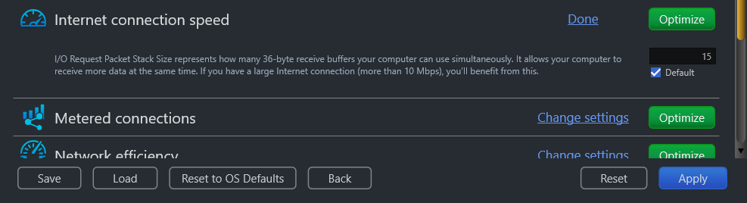
Figure 21 – Internet connection speed easel
- Change the I/O Request Packet Stack Size parameter as per your requirements and click the Optimize button. The green Optimize button is replaced by a blue Pending button.

Tip: Click the Default checkbox to revert to the default parameter settings. You can also click the Done link to close this easel.

Tip: In case you want to revert to the previous settings, click Revert.

Tip: To save your current settings, click Save. The Saves As dialog box is displayed which enables you to specify a folder location on your hard disk drive to save your current settings as a NetOptimizer presets (*.nop) settings file. You can also save these settings on a USB thumb drive in case you want to load these settings on another system.

Tip: To load previously saved settings, click Load. The Open dialog box is displayed which enables you to navigate to the previously saved NetOptimizer presets (*.nop) settings file.

Tip: To revert to the default settings of your operating system, click Reset to OS Defaults. NetOptimizerTM will reset all settings to default values of your Operating System.

Tip: To return to the NetOptimizerTM default screen, click Back.

- Click Apply to apply your updated settings.

Tip: The system will prompt you to Restart your system. Click Yes to continue restarting your system or you can choose to click No to make changes to other settings.

Tip: After you have restarted your system, a green checkbox will be displayed against the optimized and saved setting.

Optimizing Metered Connection Settings
To optimize metered connection settings, the NetOptimizerTM application optimizes the Connection Type setting – Ethernet, Wifi, 3G, & 4G

Setting the required Connection Type setting – Ethernet, Wifi, 3G, & 4G governs which internet connection types are to be optimized. Typically, cellular connections like 3G & 4G are set as metered connections which have an upper data limit usage set for them. Wifi & Ethernet are not set as metered connections by default. Some apps might work differently on a metered connection to help reduce your data usage.

When the Connection Type is set incorrectly as per your network setup, your computer spends more time waiting for a packet to deliver depending in case your connection is metered, effectively decreasing the productivity in your network.

The steps described below enable you to optimize metered connection settings of your system –
- From the Advanced Mode screen of the NetOptimizerTM application, click the Change Settings link as depicted in the figure below –
SANITIZED

SANITIZED

Figure 22 – Advanced Mode screen

The Metered connection easel is opened as depicted in the figure below –
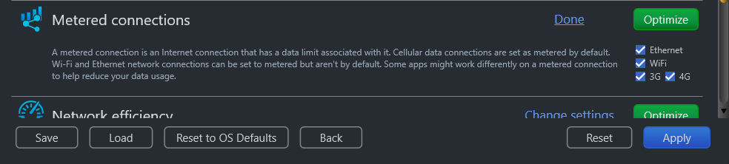
Figure 23 – Metered connection easel
- Select the appropriate Connection Type setting – Ethernet, Wifi, 3G, and / or 4G checkbox as per your requirements and click the Optimize button. The green Optimize button is replaced by a blue Pending button.

Tip: Click the Default checkbox to revert to the default parameter settings. You can also click the Done link to close this easel.

Tip: In case you want to revert to the previous settings, click Revert.

Tip: To save your current settings, click Save. The Saves As dialog box is displayed which enables you to specify a folder location on your hard disk drive to save your current settings as a NetOptimizer presets (*.nop) settings file. You can also save these settings on a USB thumb drive in case you want to load these settings on another system.

Tip: To load previously saved settings, click Load. The Open dialog box is displayed which enables you to navigate to the previously saved NetOptimizer presets (*.nop) settings file.

Tip: To revert to the default settings of your operating system, click Reset to OS Defaults. NetOptimizerTM will reset all settings to default values of your Operating System.

Tip: To return to the NetOptimizerTM default screen, click Back.

- Click Apply to apply your updated settings.

Tip: The system will prompt you to Restart your system. Click Yes to continue restarting your system or you can choose to click No to make changes to other settings.

Tip: After you have restarted your system, a green checkbox will be displayed against the optimized and saved setting.

Optimizing Network Efficiency Settings
To optimize network efficiency settings, the NetOptimizerTM application optimizes the Time to Live setting.

The Time to Live (TTL) setting tells each of the routers between your system and the intended target server as to how long a data packet should persist in your network while it attempts delivery before abandoning delivery and discarding the aforementioned data packet.

When the value is set high, your computer spends more time waiting for a failed packet to deliver, effectively decreasing the amount of productivity in your network.

The steps described below enable you to optimize network efficiency settings of your system –
- From the Advanced Mode screen of the NetOptimizerTM application, click the Change Settings link as depicted in the figure below –
SANITIZED

SANITIZED

Figure 24 – Advanced Mode screen

The Network efficiency easel is opened as depicted in the figure below –
Figure 25 – Network efficiency easel
- Change the Time to Live (TTL) parameter as per your requirements and click the Optimize button. The green Optimize button is replaced by a blue Pending button.

Tip: Click the Default checkbox to revert to the default parameter settings. You can also click the Done link to close this easel.

Tip: In case you want to revert to the previous settings, click Revert.

Tip: To save your current settings, click Save. The Saves As dialog box is displayed which enables you to specify a folder location on your hard disk drive to save your current settings as a NetOptimizer presets (*.nop) settings file. You can also save these settings on a USB thumb drive in case you want to load these settings on another system.

Tip: To load previously saved settings, click Load. The Open dialog box is displayed which enables you to navigate to the previously saved NetOptimizer presets (*.nop) settings file.

Tip: To revert to the default settings of your operating system, click Reset to OS Defaults. NetOptimizerTM will reset all settings to default values of your Operating System.

Tip: To return to the NetOptimizerTM default screen, click Back.

- Click Apply to apply your updated settings.

Tip: The system will prompt you to Restart your system. Click Yes to continue restarting your system or you can choose to click No to make changes to other settings.

Tip: After you have restarted your system, a green checkbox will be displayed against the optimized and saved setting.

Optimizing Network Performance Settings
To optimize network performance settings, the NetOptimizerTM application optimizes the Time to Live setting.

The Time to Live (TTL) setting tells each of the routers between your system and the intended target server as to how long a data packet should persist in your network while it attempts delivery before abandoning delivery and discarding the aforementioned data packet.

When the value is set high, your computer spends more time waiting for a failed packet to deliver, effectively decreasing the amount of productivity in your network.

The steps described below enable you to optimize network performance settings of your system –
- From the Advanced Mode screen of the NetOptimizerTM application, click the Change Settings link as depicted in the figure below –
SANITIZED

SANITIZED

Figure 26 – Advanced Mode screen

The Network performance easel is opened as depicted in the figure below –
Figure 27 – Network performance easel
- Change the Time to Live (TTL) parameter as per your requirements and click the Optimize button. The green Optimize button is replaced by a blue Pending button.

Tip: Click the Default checkbox to revert to the default parameter settings. You can also click the Done link to close this easel.

Tip: In case you want to revert to the previous settings, click Revert.

Tip: To save your current settings, click Save. The Saves As dialog box is displayed which enables you to specify a folder location on your hard disk drive to save your current settings as a NetOptimizer presets (*.nop) settings file. You can also save these settings on a USB thumb drive in case you want to load these settings on another system.

Tip: To load previously saved settings, click Load. The Open dialog box is displayed which enables you to navigate to the previously saved NetOptimizer presets (*.nop) settings file.

Tip: To revert to the default settings of your operating system, click Reset to OS Defaults. NetOptimizerTM will reset all settings to default values of your Operating System.

Tip: To return to the NetOptimizerTM default screen, click Back.

- Click Apply to apply your updated settings.

Tip: The system will prompt you to Restart your system. Click Yes to continue restarting your system or you can choose to click No to make changes to other settings.

Tip: After you have restarted your system, a green checkbox will be displayed against the optimized and saved setting.

Optimizing Network Throughput Settings
To optimize network throughput settings, the NetOptimizerTM application optimizes the Time to Live setting.

The Time to Live (TTL) setting tells each of the routers between your system and the intended target server as to how long a data packet should persist in your network while it attempts delivery before abandoning delivery and discarding the aforementioned data packet.

When the value is set high, your computer spends more time waiting for a failed packet to deliver, effectively decreasing the amount of productivity in your network.

The steps described below enable you to optimize network throughput settings of your system –
- From the Advanced Mode screen of the NetOptimizerTM application, click the Change Settings link as depicted in the figure below –
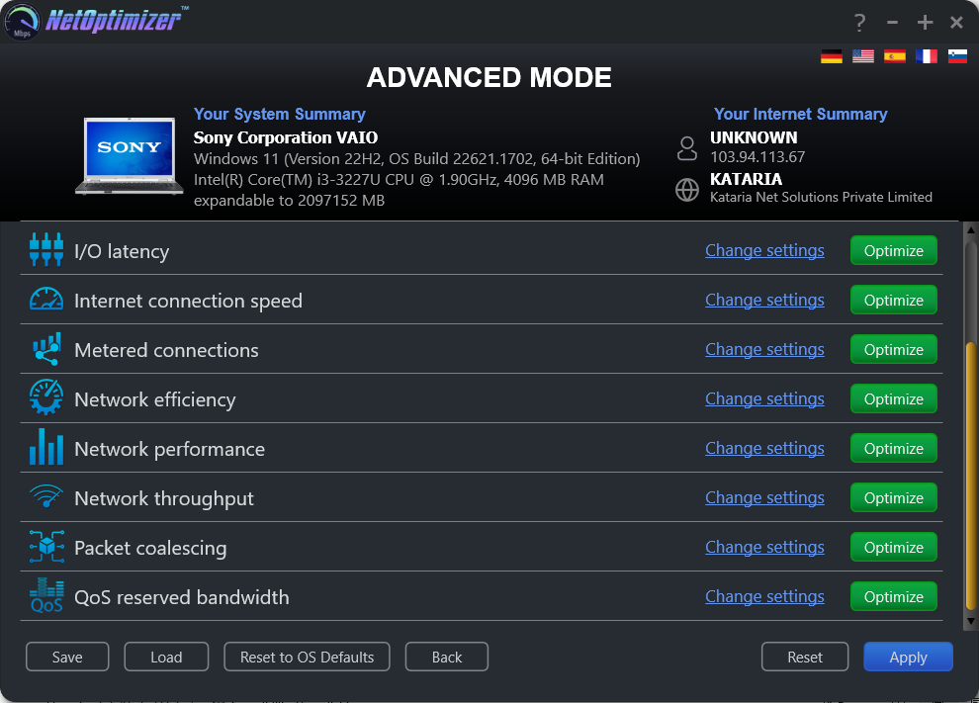
SANITIZED

SANITIZED

Figure 28 – Advanced Mode screen

The Network throughput easel is opened as depicted in the figure below –
Figure 29 – Network throughput easel
- Change the Time to Live (TTL) parameter as per your requirements and click the Optimize button. The green Optimize button is replaced by a blue Pending button.

Tip: Click the Default checkbox to revert to the default parameter settings. You can also click the Done link to close this easel.

Tip: In case you want to revert to the previous settings, click Revert.

Tip: To save your current settings, click Save. The Saves As dialog box is displayed which enables you to specify a folder location on your hard disk drive to save your current settings as a NetOptimizer presets (*.nop) settings file. You can also save these settings on a USB thumb drive in case you want to load these settings on another system.

Tip: To load previously saved settings, click Load. The Open dialog box is displayed which enables you to navigate to the previously saved NetOptimizer presets (*.nop) settings file.

Tip: To revert to the default settings of your operating system, click Reset to OS Defaults. NetOptimizerTM will reset all settings to default values of your Operating System.

Tip: To return to the NetOptimizerTM default screen, click Back.

- Click Apply to apply your updated settings.

Tip: The system will prompt you to Restart your system. Click Yes to continue restarting your system or you can choose to click No to make changes to other settings.

Tip: After you have restarted your system, a green checkbox will be displayed against the optimized and saved setting.

Optimizing Packet Coalescing Settings
To optimize packet coalescing settings, the NetOptimizerTM application optimizes the Time to Live setting.

The Time to Live (TTL) setting tells each of the routers between your system and the intended target server as to how long a data packet should persist in your network while it attempts delivery before abandoning delivery and discarding the aforementioned data packet.

When the value is set high, your computer spends more time waiting for a failed packet to deliver, effectively decreasing the amount of productivity in your network.

The steps described below enable you to optimize packet coalescing settings of your system –
- From the Advanced Mode screen of the NetOptimizerTM application, click the Change Settings link as depicted in the figure below –
SANITIZED

SANITIZED

Figure 30 – Advanced Mode screen

The Packet coalescing easel is opened as depicted in the figure below –
Figure 31 – Packet coalescing easel
- Change the Time to Live (TTL) parameter as per your requirements and click the Optimize button. The green Optimize button is replaced by a blue Pending button.

Tip: Click the Default checkbox to revert to the default parameter settings. You can also click the Done link to close this easel.

Tip: In case you want to revert to the previous settings, click Revert.

Tip: To save your current settings, click Save. The Saves As dialog box is displayed which enables you to specify a folder location on your hard disk drive to save your current settings as a NetOptimizer presets (*.nop) settings file. You can also save these settings on a USB thumb drive in case you want to load these settings on another system.

Tip: To load previously saved settings, click Load. The Open dialog box is displayed which enables you to navigate to the previously saved NetOptimizer presets (*.nop) settings file.

Tip: To revert to the default settings of your operating system, click Reset to OS Defaults. NetOptimizerTM will reset all settings to default values of your Operating System.

Tip: To return to the NetOptimizerTM default screen, click Back.

- Click Apply to apply your updated settings.

Tip: The system will prompt you to Restart your system. Click Yes to continue restarting your system or you can choose to click No to make changes to other settings.

Tip: After you have restarted your system, a green checkbox will be displayed against the optimized and saved setting.

Optimizing QoS Reserved Bandwidth Settings
To optimize QoS reserved bandwidth settings, the NetOptimizerTM application optimizes the Time to Live setting.

The Time to Live (TTL) setting tells each of the routers between your system and the intended target server as to how long a data packet should persist in your network while it attempts delivery before abandoning delivery and discarding the aforementioned data packet.

When the value is set high, your computer spends more time waiting for a failed packet to deliver, effectively decreasing the amount of productivity in your network.

The steps described below enable you to optimize QoS reserved bandwidth settings of your system –
- From the Advanced Mode screen of the NetOptimizerTM application, click the Change Settings link as depicted in the figure below –
SANITIZED

SANITIZED

Figure 32 – Advanced Mode screen

The QoS reserved bandwidth easel is opened as depicted in the figure below –
Figure 33 – QoS reserved bandwidth easel
- Change the Time to Live (TTL) parameter as per your requirements and click the Optimize button. The green Optimize button is replaced by a blue Pending button.

Tip: Click the Default checkbox to revert to the default parameter settings. You can also click the Done link to close this easel.

Tip: In case you want to revert to the previous settings, click Revert.

Tip: To save your current settings, click Save. The Saves As dialog box is displayed which enables you to specify a folder location on your hard disk drive to save your current settings as a NetOptimizer presets (*.nop) settings file. You can also save these settings on a USB thumb drive in case you want to load these settings on another system.

Tip: To load previously saved settings, click Load. The Open dialog box is displayed which enables you to navigate to the previously saved NetOptimizer presets (*.nop) settings file.

Tip: To revert to the default settings of your operating system, click Reset to OS Defaults. NetOptimizerTM will reset all settings to default values of your Operating System.

Tip: To return to the NetOptimizerTM default screen, click Back.

- Click Apply to apply your updated settings.

Tip: The system will prompt you to Restart your system. Click Yes to continue restarting your system or you can choose to click No to make changes to other settings.

Tip: After you have restarted your system, a green checkbox will be displayed against the optimized and saved setting.

The next chapter describes steps that enable you to view the Wi-Fi Passwords of the wifi connection that your system is connected to.

Viewing the Wi-Fi Passwords
The steps described below enable you to view the wifi password of the connection that your system is connected to –
- From the default screen of the NetOptimizerTM application, click the Wi-Fi Passwords button as depicted in the figure below.
SANITIZED

SANITIZED

Figure 34 – Viewing the Wi-Fi Passwords
The Wi-Fi Passwords screen is displayed as depicted in the figure below –
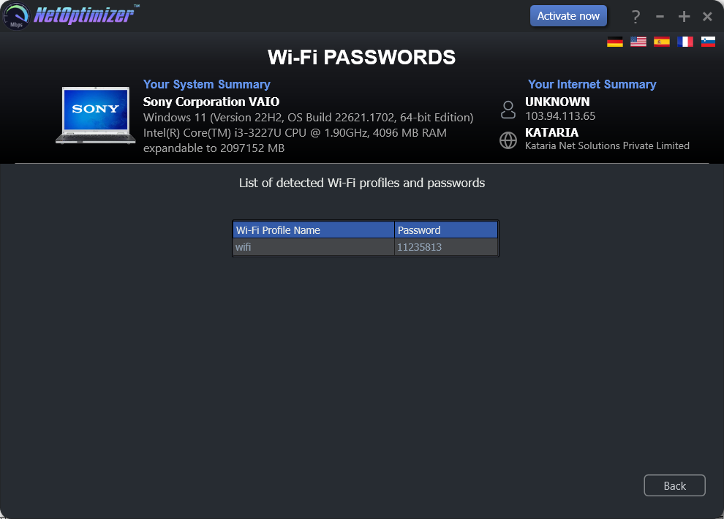
SANITIZED

SANITIZED

Figure 35 – Automatic execution of the Auto Mode system analysis wizard
- Click Back to return to the NetOptimizerTM default screen.

The next chapter describes steps that enable you to use the Browser Cleanup feature of the NetOptimizer TM application.

Using the Browser Cleanup Feature
The steps described below enable you to use the browser cleanup feature of the NetOptimizerTM application –
- From the default screen of the NetOptimizerTM application, click the Browser Cleanup button as depicted in the figure below.
SANITIZED

SANITIZED

Figure 36 – Using the Browser Cleanup Feature
The Browser Cleanup screen is displayed as depicted in the figure below –
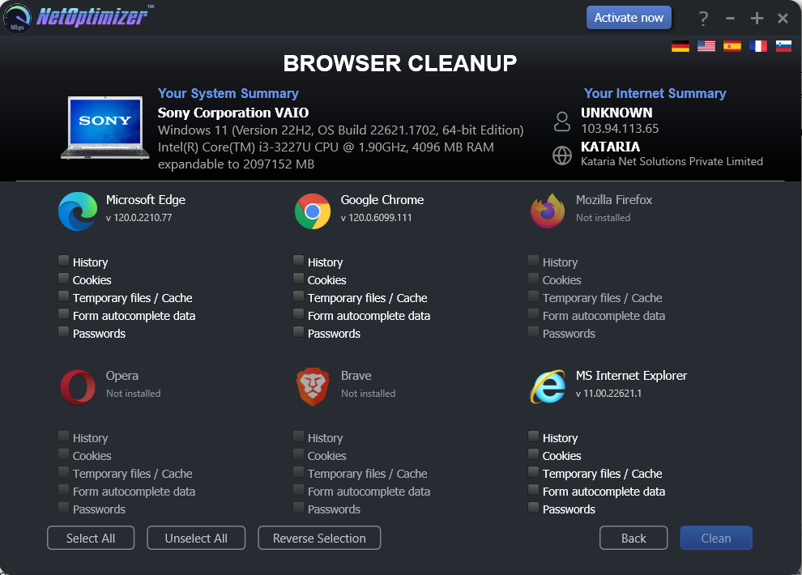
SANITIZED

SANITIZED

Figure 37 – Browser cleanup screen
- You can specify which cleaning tasks are to be performed by clicking the corresponding checkboxes for each browser one-by-one or you can click the Select All button to select all checkbox options. You can also click Unselect All to unselect any or all checkboxes that you may have previously selected or you can click Remove Selection to remove your selections.
Tip: You can only select corresponding options for the web-browsers that are installed on your system. The Clean button will only be enabled once you make at least one selection for the installed browser of your choice.

- Click Clean to clean your web browsers as per your selections. The NetOptimizerTM application will query you to continue the cleanup procedure as per your selections as depicted in the figure below –

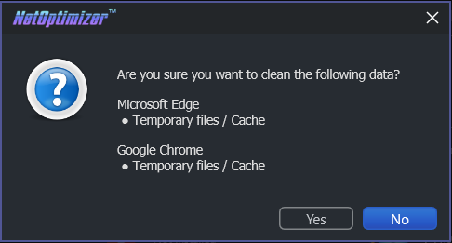
Figure 38 – Querying for Cleanup task confirmation

- Click Yes to continue cleaning up the specified web-browser(s) or click No abort continuing with this cleanup task.
Tip: You can change your selections by repeating steps 2 and 3 described in this section or you can click Back to return the NetOptimizerTM default screen.

- In case your web-browsers are open, the application will prompt you to close them as depicted in the figure below –

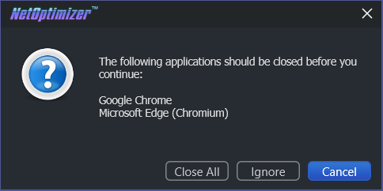
Figure 39 – Querying for closing open web-browsers

- Click Close All to close your web-browsers.
Tip: Click Ignore to perform the cleanup task without closing your web-browsers.

Once the cleanup task has been completed, a popup confirming the same will be displayed as depicted in the figure below –
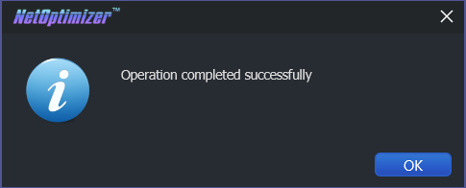
Figure 40 – Successful Operation completion status message

- Click OK to continue. You will be viewing the Browser Cleanup screen as depicted in the figure below-
SANITIZED

SANITIZED

Figure 41 – Browser cleanup screen

- Click Back to return to the NetOptimizerTM default screen.

The next chapter describes steps that enable you to use the Diagnostic Troubleshooting feature of the NetOptimizer TM application.

Using the Diagnostic Troubleshooting Feature
The steps described below enable you to use the diagnostic troubleshooting feature of your system –
- From the default screen of the NetOptimizerTM application, click the Click here link as depicted in the figure below.
SANITIZED

SANITIZED

Figure 42 – Using the Diagnostic Troubleshooting Feature
The Diagnostic Troubleshooting screen is displayed as depicted in the figure below –
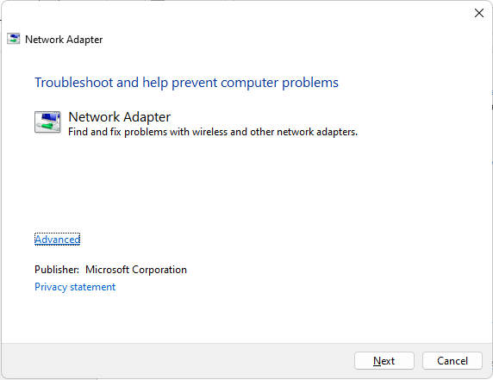
Figure 43 – Diagnostic troubleshooting wizard
- Click Next to execute the Diagnostic Troubleshooting wizard or click Cancel to return to the NetOptimizerTM default screen.
Tip: For more information, refer to the user manual of your operating system.
The next chapter describes steps that enable you to Activate your NetOptimizerTM installation.

Activating your NetOptimizerTM Installation
In case you have not activated your NetOptimizerTM application while using the Auto Mode network optimization wizard, you can utilize the steps described below which enable you to activate your NetOptimizerTM application installation –
- From the default screen of the NetOptimizerTM application, click the Activate Now button as depicted in the figure below.
SANITIZED

SANITIZED

Figure 44 – Activating your NetOptimizerTM Installation
The Key Application popup is displayed as depicted in the figure below –
Figure 45 – Key application popup
- Click the Buy Now button to avail the money saving offer depicted here.
Tip: You will be navigated to the NetOptimizerTM shopping cart web page in your default web browser. You can specify the required details, and click Buy Now on this web page to make your purchase. You will receive an email containing your license key details at the email address specified by you on this web page.

- Once you have received your license key, specify your email address and license key and click the Submit button. After successful validation of the specified key, your NetOptimizerTM installation will be activated and a popup will be displayed confirming the same as depicted in the figure below –

Figure 46 – Successful application of your license key

- Click Continue to continue using the NetOptimizerTM application. The Activate Now button will be removed from the NetOptimizerTM default screen.

Tip: To view the license details, you can click the Question Mark (?) button on the NetOptimizerTM default screen.

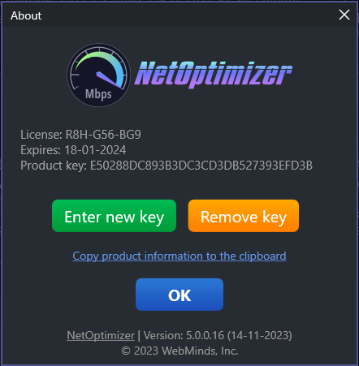
SANITIZED

Figure 47 – Viewing your license key details
- Click Enter New Key in case you intend to specify a new license key or click OK to continue using the NetOptimizerTM application.
Tip: Click the Copy product information to the clipboard link to copy the license details. You can paste this key in a document of your choice for safekeeping.
The next chapter describes steps that enable you to Remove your NetOptimizerTM license key.

Removing your NetOptimizerTM License Key
Once you have activated your NetOptimizerTM application with a valid license key which has not expired yet, you can utilize the steps described below which enable you to remove this key so that you can reuse it on another system or the same system at a later date provided it has not expired –
- From the default screen of the NetOptimizerTM application, click the Question Mark (?) button as depicted in the figure below.
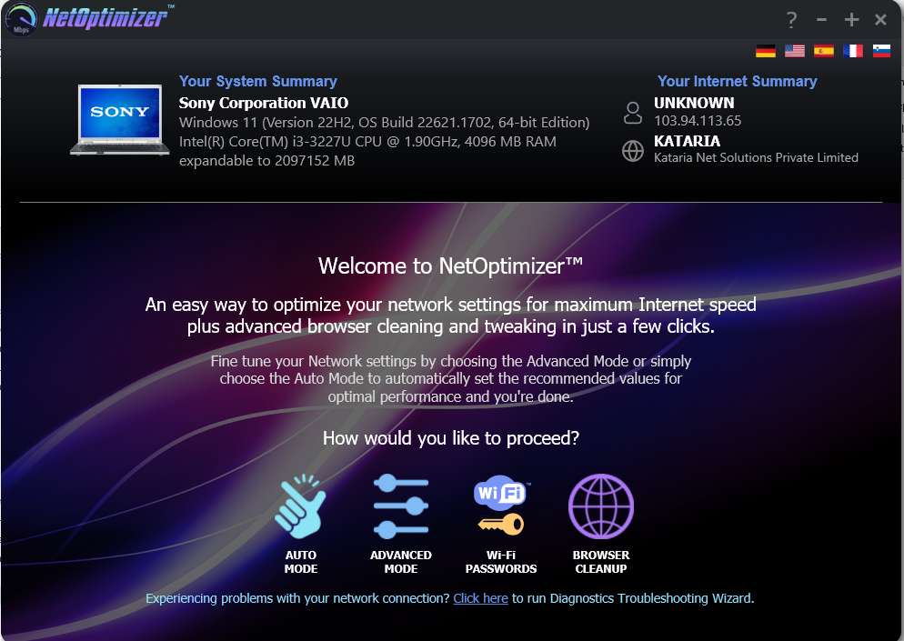
SANITIZED

SANITIZED

Figure 48 – Removing your NetOptimizerTM License Key
The About popup is displayed as depicted in the figure below –
SANITIZED

Figure 49 – Viewing your license key details
- Click Remove Key to remove your license key.
Tip: Click the Copy product information to the clipboard link to copy the license details. You can paste this key in a document of your choice for safekeeping.
- After you have clicked on Remove Key, the application will query you for your confirmation as depicted in the figure below –

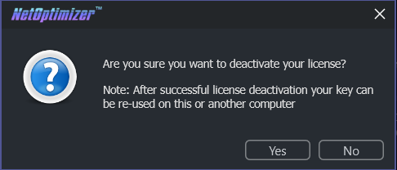
Figure 50 – License key deactivation confirmation message

- Click Yes to continue to deactivating your license key or click No to continue using your already specified license key. If you clicked Yes, a deactivation successful status message will be displayed as depicted in the figure below –

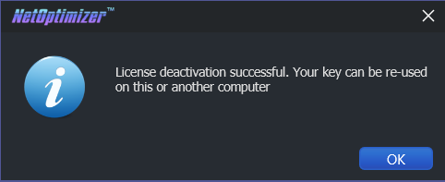
Figure 51 – License key deactivation successfully status message

- Click Ok to continue using the NetOptimizerTM application.

The next section of this user manual lists an index describing key points of this user manual. This information navigation aid enables you to quickly lookup required information.

- Frequently Asked Questions (FAQs)
Here is a list of frequently asked questions with reference to the NetOptimizerTM application and its usage –
How can NetOptimizer™ help me?
NetOptimizerTM is an advanced system utility that checks your computer for non-optimal Internet connection settings and enables you to apply the best possible settings for your connection type automatically. With its help, you’ll be able to fine-tune your PC to get the actual connection speed as advertised by your Internet service provider.

Do I need to install NetOptimizer™ on my computer?
Yes. After you have downloaded the single-click executable .exe file from the below link, you can install the application by following the easy-to-use installation wizard.

Reference: To download the NetOptimizerTM application installer, click the following link – https://www.netoptimizer.com/files/NetOptimizer.exe. The system may prompt you to restart itself to finish installing the NetOptimizerTM application. Please save your work and restart your system at this point.

What are the minimum system requirements for NetOptimizer™?
The minimum system requirements for NetOptimizerTM are:

- Windows XP SP3 or newer
- 1 GHz CPU (both 32-bit and 64-bit platforms are supported)
- 128 MB RAM
- 32 MB disk space
- Screen size of 1024×768 or larger

Which versions of Windows is NetOptimizer™ compatible with?
NetOptimizerTM is compatible with the following versions of Windows –

- Windows XP
- Windows Vista
- Windows 7
- Windows 8
- Windows 10
- Windows 11

Which settings can I optimize with NetOptimizer™?
NetOptimizerTM fine-tunes hidden Windows network settings such as TCP settings, TTL, I/O parameters, and network efficiency.

Reference: For more information, see Using the Advanced Mode chapter.

Does NetOptimizer™ support metered connections?
Yes, NetOptimizerTM has a special setting for metered connections and can optimize your PC’s network settings for best results on 3G, 4G, and 5G.

How does NetOptimizer™ know the best settings for my computer?
NetOptimizerTM quickly checks your Internet connection type and your operating system’s parameters to determine if anything needs to be adjusted. If your settings are already optimal, you’ll see green checkmarks next to those settings.

Is NetOptimizer™ safe to use?
Yes, NetOptimizerTM is absolutely safe to use because you can always undo any changes made by the application by clicking on the Reset to OS Defaults button on the Advanced Mode screen.

Reference: For more information, see Using the Advanced Mode chapter.

What are the trial version limitations?
The trial version of NetOptimizer lets you find the optimal Internet connection settings but it doesn’t let you apply & save them. For that, you’ll need to purchase a license.

Reference: For more information, click the Buy Now button on the NetOptimizerTM official website page header or use this link – https://www.netoptimizer.com/cart/

Why is there an expiration date on my NetOptimizerTM license?
When you purchase a license for NetOptimizerTM, the license unlocks the program forever, so that you can use NetOptimizer for as long as you want. As for the expiry date, it’s set to show you the period during which you will be able to download free updates. Once the license expires, you can continue using your version of the program, but you will need to extend your license to continue getting updates and have access to email support.

Tip: Remember that each computer is assigned a unique license ID. Once activated, this license will not work on any other computer while it is being used on a given system provided it is still valid.

Can I reuse my license on another system?
Yes. You can reuse you existing valid license on another system but you will first require removing it from the system it is being used currently.

Tip: For more information, see Removing your NetOptimizerTM License Key & Activating your NetOptimizerTM Installation chapters.

Warning: Ensure to remove your existing valid license before resetting or reformatting your current Windows installation.

I’m trying to register NetOptimizer but it’s not working. What to do?
There may be a few issues that may prevent the activation of the product, including:

Your UAC (User Account Control) settings in Windows Vista, Windows 7, Windows 8, Windows 10 and Windows 11. When that’s the case, close NetOptimizerTM, then right-click on its shortcut on your desktop and select Run as administrator. Then proceed to register the program.

Your firewall or anti-virus programs may be preventing changes to your computer. Even the changes such as registering your product. Try disabling your security software temporarily and proceed with product registration.

Tip: In case you are still facing issues, please fill the Get in Touch form provided on the Support page and submit your details along with the issue you are facing. To do so, click the following link – https://www.netoptimizer.com/support/. We are more than happy to assist you in using the NetOptimizerTM application.

The next section of this user manual includes a list of frequently asked questions with reference to the NetOptimizerTM application and its usage.

Index

A
Abbreviations / Acronyms used in this User Manual v
About this User Manual iii
Activating your NetOptimizerTM Installation 46
C
Can I reuse my license on another system? 52
D
Do I need to install NetOptimizer™ on my computer? 50
Does NetOptimizer™ support metered connections? 51
F
Frequently Asked Questions (FAQs) 50
G
Getting Started 10
H
How can NetOptimizer™ help me? 50
How does NetOptimizer™ know the best settings for my computer? 51
I
I’m trying to register NetOptimizer but it’s not working. What to do? 53
In Scope of this User Manual iii
Intended Audience of this User Manual iii
Introduction 9
Is NetOptimizer™ safe to use? 51
O
Optimizing Data Caching Settings 16
Optimizing DNS Server Settings 18
Optimizing Host Resolution Priority Settings 21
Optimizing I/O Latency Settings 23
Optimizing Internet Connection Speed Settings 25
Optimizing Metered Connection Settings 27
Optimizing Network Efficiency Settings 29
Optimizing Network Performance Settings 31
Optimizing Network Throughput Settings 33
Optimizing Packet Coalescing Settings 36
Optimizing QoS Reserved Bandwidth Settings 38
Organization of this User Manual v
Out of Scope of this User Manual iii
P
Purpose of this User Manual iii
R
Removing your NetOptimizerTM License Key 48
S
Scope of this User Manual iii
T
Terms Used in this User Manual v
Typographical Conventions / Customaries used in this User Manual iv
U
Using the Advanced Mode 15
Using the Auto Mode 12
Using the Browser Cleanup Feature 42
Using the Diagnostic Troubleshooting Feature 45
V
Viewing the Wi-Fi Passwords 41
W
What are the minimum system requirements for NetOptimizer™? 50
What are the trial version limitations? 52
Which settings can I optimize with NetOptimizer™? 51
Which versions of Windows is NetOptimizer™ compatible with? 51
Why is there an expiration date on my NetOptimizerTM license? 52

